We can measure the actual running time of the execution of an algorithm.”
(True / False)
Answer: True
The actual running time of an algorithm can be measured by executing the program on a specific machine with a specific input. However, it depends on hardware and environment, which is why we use Big-O notation for theoretical analysis.
Rearrange the following functions (f1, f2, f3, and f4) in increasing order of asymptotic complexity:
f1(n) = n^{(3/2)} , f2(n) = 2^{n} , f3(n) = n^{log(n)}, f4(n) = n*log(n)
This type of question, Follow the below sequence
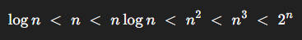

Why do we ignore the coefficient of the leading term in Time Complexity?
In time complexity analysis, we focus on how an algorithm grows when the input size n becomes very large.
In the figure, we see functions like:
- 5n+5
- n^2
- 0.001n^2

Key Observation from the Figure:
- When n is small, a function like 5n+5 may appear larger than 0.001n^2.
- But when n becomes very large, the n^2 function grows much faster than the linear function 5n+5.
- Although the coefficient is small, a higher power term (like n²) grows much faster than a lower power term (like n). As n becomes large, the higher power term eventually dominates.
OR
Even if the coefficient is very small (like 0.001), the term with the higher power (n²) will eventually dominate.

Two important properties that an algorithm should have are:
1️⃣ Correctness (সঠিকতা)
অ্যালগরিদমটি প্রতিটি বৈধ ইনপুটের জন্য সঠিক আউটপুট দিতে হবে।
অর্থাৎ, সমস্যা যেটা সমাধান করার কথা, সেটি ঠিকভাবে সমাধান করতে হবে।
2️⃣ Finiteness (সীমাবদ্ধতা)
অ্যালগরিদম অবশ্যই নির্দিষ্ট সংখ্যক ধাপের পর শেষ হতে হবে।
অর্থাৎ, এটি অসীম লুপে চলতে পারবে না — একসময় থামতেই হবে।
1️⃣ Correctness
The algorithm must produce the correct output for every valid input.
It should properly solve the problem it is designed to solve.
2️⃣ Finiteness
The algorithm must terminate after a finite number of steps.
It should not run forever (no infinite loops).

Insertion sort times complexity:

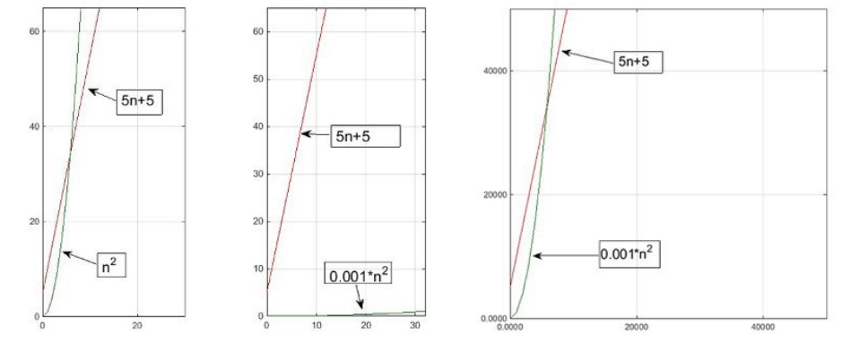
Asymptotic Notations:
O-notation (Big Oh)
Big-O notation represents the asymptotic upper bound of an algorithm.
It describes how the running time grows when the input size ( n ) becomes very large.

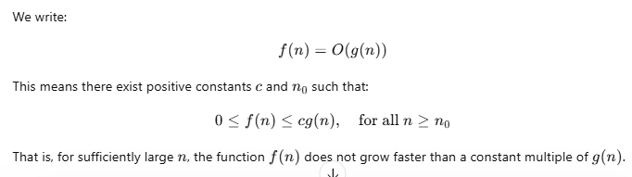Important Points:
- Big-O shows the worst-case growth rate.
- Keep the highest power term.
- Ignore coefficients.
- Ignore lower order terms.

Example:
T(n) = 3n^2 + 10n + 8
The highest order term is ( n^2 ).
Therefore,
T(n) = O(n^2)
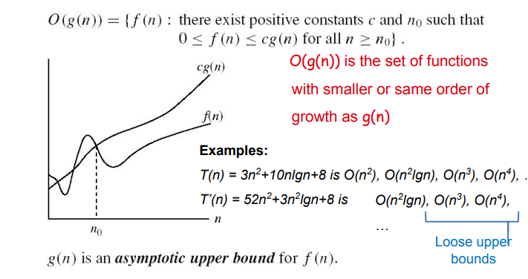 Ω-Notation (Big Omega)
Big-Omega notation represents the asymptotic lower bound of an algorithm.
It describes the minimum growth rate of a function for large input size ( n ).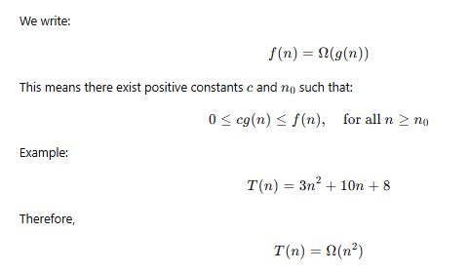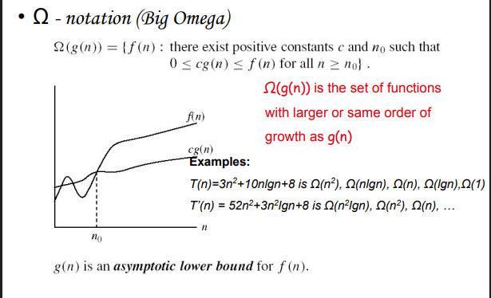
Notation (Big Theta)
Big-Theta notation represents the asymptotically tight bound of a function.
It describes the exact growth rate of an algorithm.
